

Metric Web App

Author: Tyler Lu

Contents

1. Create SharePoint Data Structure 2

1.1. Create a site collection if it is needed 2

1.2. Provision site columns, content types and lists 4

1.3. Add preset data 4

2. Metric Web App 5

2.1. Create App registrations in AAD 5

2.2. Create a Web App on Azure 6

3. Follow-up steps 7

3.1. Add Reply URL to the App Registration 7

3.2. Admin consent 8

# Create SharePoint Data Structure

## Create a site collection if it is needed

1. Open a web browser and go to SharePoint Administration Center.

*https://<Your Tenant> -admin.sharepoint.com/_layouts/15/online/SiteCollections.aspx*

1. Click **New** -> **Private Site Collection**.

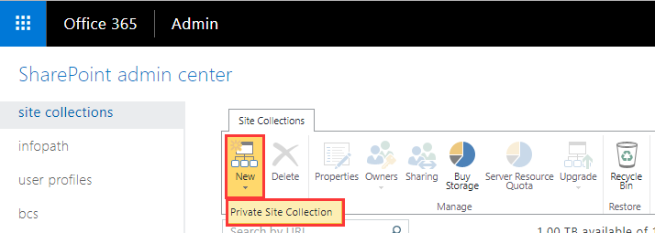

1. Fill in the form:

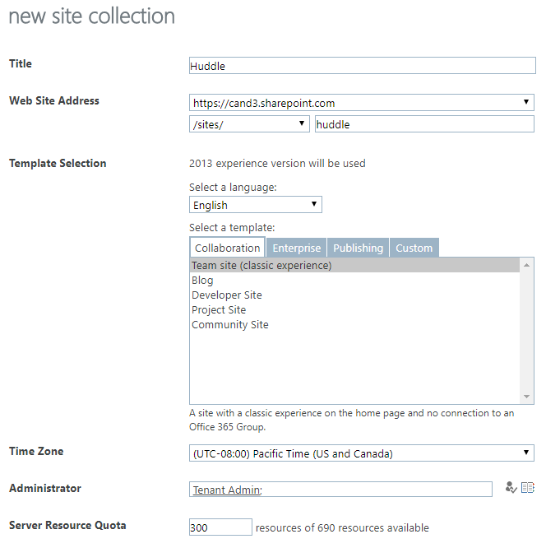

* + In the **Title** field, enter site title.
  + In the **Web Site Address** field, enter hospital site URL.
  + **Select a language** = English
  + In the **Template Selection** section, select **Team Site** assite template.
  + **Time Zone** should be (UTC-08:00) Pacific Time (US and Canada)
  + **Administrator** should be the alias of the individual you want to have full administrator rights on this site.
  + **Storage Quote** is how much space you will need for the assets for the end user
  + **Leave Server Resource Quota** at 300. (This value can be adjusted later if needed)

1. Click **OK**

## Provision site columns, content types and lists

1. Install SharePointPnPPowerShellOnline module, if you have not installed it.

Please follow:

<https://msdn.microsoft.com/en-us/pnp_powershell/pnp-powershell-overview#installation>

1. Open Power Shell, then execute the command below to connect to the site you just created:

|  |
| --- |
| Connect-PnPOnline –Url https://*<Tenant>*.sharepoint.com/sites/*<Site>* –Credentials (Get-Credential) |

Note: please replace *<Tenant>* and *<Site>*

1. Login in with an admin account.

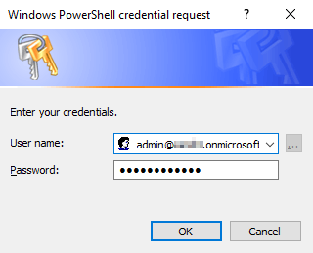

1. Navigate to /Files folder in PowerShell, then execute the following command:

|  |
| --- |
| Apply-PnPProvisioningTemplate -Path PnPProvisioningTemplate.xml |

## Add preset data

Add the some categories to the Categories list, for example:

* Safety/Quality
* Access
* Experience
* Finance
* People

# Metric Web App

## Create App registrations in AAD

1. Navigate to the Huddle AAD you want register the app.

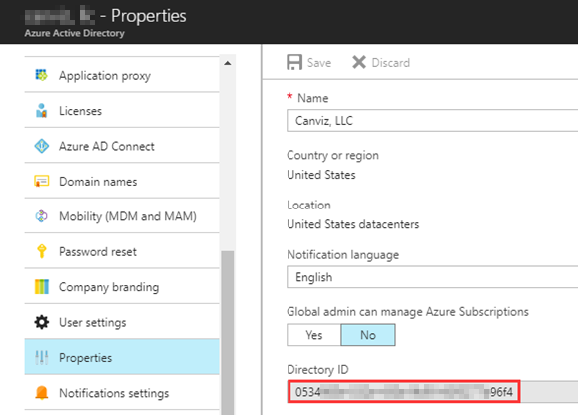

Copy aside the Directory Id. It will be used as the value of ida:TenantId App setting.

1. Create an App Registration in AAD with the following settings:

* **Name**: Huddle Metric Web App
* **Application Type**: Web app/API
* **Sign-on URL**: https://<Your Domain>/metric-web-app
* **Required Permissions**:

|  |  |
| --- | --- |
| API | Permissions |
| Office 365 SharePoint Online  (Microsoft.SharePoint) | Application Permissions:   * Read and write items and lists in all site collections |
| Windows Azure Active Directory (Microsoft.Azure.ActiveDirectory) | Delegated Permissions:   * Read directory data * Sign in and read user profile |

1. After the App Registration created:

* Copy aside the Application ID. It will be used as the value of ida:ClientID App setting.

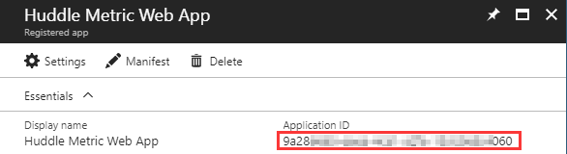

* Create a new key, and copy aside its value. The value will be used as the value of ida:ClientSecret App setting.

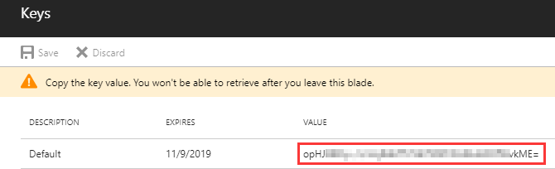

1. Follow chapter 3 in *2. App-only certificate.docx* to add keyCredential of the certificate to the manifest of the app registration.

## Create a Web App on Azure

1. Create a Web in Azure with the following App settings:

|  |  |  |
| --- | --- | --- |
|  | Key | Value |
| AAD & App Registration | ida:TenantId | Use the corresponding value you got from previous registered app. |
| ida:ClientId |
| ida:ClientSecret |
| Certificate | Ida:ClientCertThumbprint | Use the thumbprint of the certificate you created ealier. |
| WEBSITE_LOAD_CERTIFICATES |
| SharePoint | BaseSPSiteUrl | Use the sharepoint site collection url created in 1.1 |
| Other | Admin | Optional. Email of the admin (Should be a user in the Huddle AAD)  This setting is only used to control the access to the clear data page (/Admin/ClearData) so far. |

After created, copy aside the URL of the website, and change the schema to https. For example:

https://huddle-metric.azurewebsites.net

This secure URL will be used in next chapter.

1. Turn on the Always On option in **Application Settings**

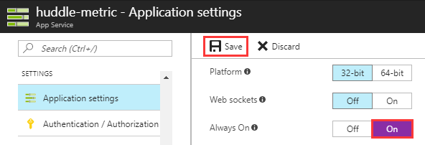

1. Upload certificate to Web App

Please follow steps in chapter 4 in *2. App-only certificate.docx*.

1. Build and Publish Huddle.MetricWebApp project to this Web App.

Note:

* Before build, please execute npm install in the directory of the project.
* After publish, please upload node_modules folder to the wwwroot folder of the Web App.
* For real use, please bundle JS files.

# Follow-up steps

## Add Reply URL to the App Registration

Go to the App registration you created in AAD.

Add a new reply URL: secure URL + /

For example: https://huddle-metric.azurewebsites.net/

## Admin consent

Build the admin consent URL: secure URL + /admin/consent

For example: <https://huddle-metric.azurewebsites.net/admin/consent>

Open the admin consent URL in browser, then sign in with an Huddle admin account:

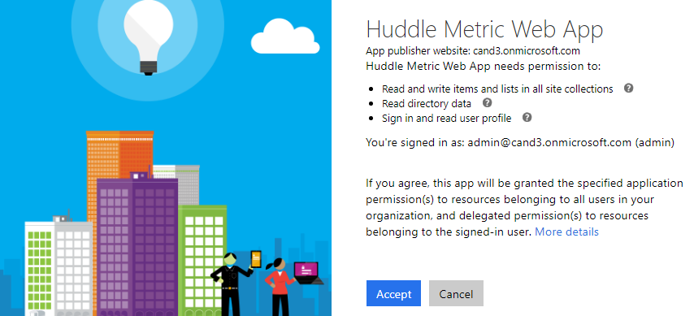

Click **Accept**.